**Review Worksheet Answers: *Homo habilis* and *Homo erectus***

1: What major difference in diet occurred between *Australopithecus* and *Homo habilis?* What evidence for this change can be seen in the fossil record?

(3 marks)

*Australopithecus primarily ate plant matter (0.5), whereas Homo habilis had a varied diet that included meat (0.5). The evidence in the fossil record for meat eating by Homo habilis includes evidence of bone that has been chopped with stone tools to extract marrow (1), and dentition and enamel that indicates a varied diet (1).*

2: Where, and during what range of time did *H. habilis* exist?

(2 marks)

*In East Africa (1), between 2.4 and 1.4 million years ago (1).*

3: What tools were *H. habilis* known to use?

*They used coarsely flaked stone choppers (1) called Oldowan choppers (1).*

5: What major changes occurred in the following areas between *H. habilis and H.erectus?*

(8 marks)

|  |  |
| --- | --- |
| **Feature** | **Change that occurred** |
| Height | *H.erectus*  *were significantly taller than H.habilis (1)* |
| Limb proportion | *H. erectus had relatively short arms and longer legs (1), proportions very similar to humans* |
| Fire Use | *There is evidence that H.erectus used fire.(1)* |
| Tools | *H.habilis used very simple stone choppers (1). H.erectus used more finely flaked Acheulean hand axes (1).* |
| Cranial Capacity | *H.erectus had a significantly larger cranial capacity than H.habilis (1050cc) compared to (610cc) (1)* |
| Distribution | *H.habilis lived only in Africa (1). H.erectus migrated into Asia and possibly Europe (1).* |

6: Circle all of the skulls that you think are likely to be *Homo erectus:*

*Hint: Think about prognathism, brow ridges, skull shape and dentition*

(1 mark)

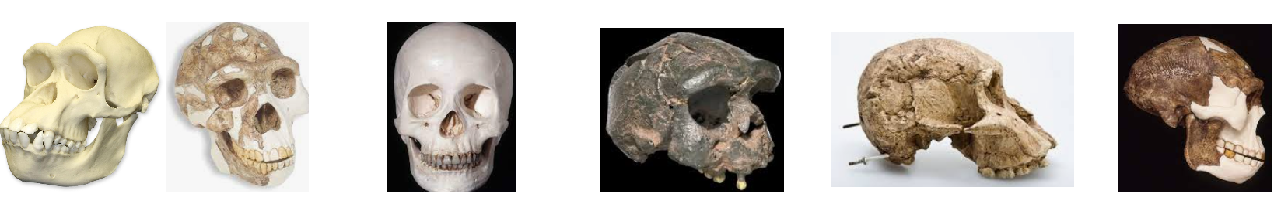

7: Fill in the table below with information about nervous system diseases.

|  |  |  |  |
| --- | --- | --- | --- |
| **Disease** | **Huntington’s (7 marks)** | **Parkinson’s (9 marks)** | **Alzheimer’s (9 marks)** |
| Cause | *Mutated gene codes for protein that damages brain. (1)* | *Cell death (1) in substantia nigra (1) in brain.* | *Plaques and tangles of protein in brain (1) progressively damage brain tissue (1)* |
| Age of Onset | *After age 40 (1)* | *Age 60-70 (1)* | *After age 65 (1)* |
| Symptoms | *Progressive dementia (1)*  *Limb flailing (1)*  *Death (1)* | *Reduced dopamine production (1)*  *Impaired motor skills (shaking) (1)*  *Impaired speech (1)* | *Memory loss (1)*  *Disorientation (1)*  *Poor judgment (1)* |
| Future Treatment | *Gene therapy (1) to splice healthy gene into brain cells (1).* | *Cell replacement therapy (1) to replace dying cells (1) with healthy cells derived from stem cells (1)* | *Cell replacement therapy (1) to replace dying cells (1) with healthy cells derived from stem cells (1)* |